W616 Quectel FW flashing through terminal
Step 1: Before flashing check, FW bin is present in /data/l26_log/L26ADRNR12A02_UPG.bin
Step 2: Goto adb shell and set the property sys.visteon.l26_service.upgrade to true using below cmd.
>>setprop sys.visteon.l26_service.upgrade true
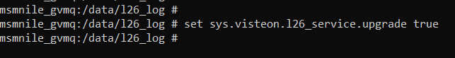
Step 3: Open another cmd terminal go to adb shell and run the below command.
>>Logcat -b all | grep -ie l26
Step 4: In First terminal Kill l26 service with PID with below commands
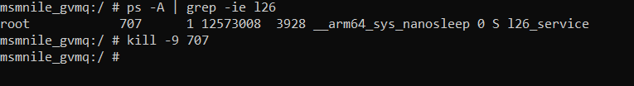

Step 7: Go to second command prompt where logs are running, FW updating logs will see like below.
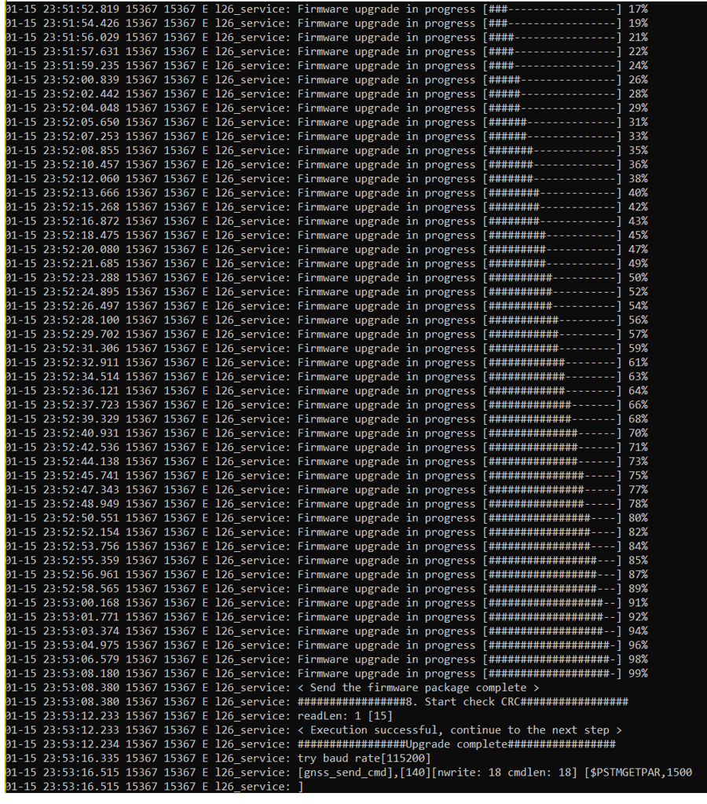

Step 8: Once FW flashing is done will see in logcat logs upgrade complete.
Step9: Latest FW version name which is flashed also checked in the same logcat logs immediately, like below. Check version name is matching with FW bin present in /data/l26_log.
